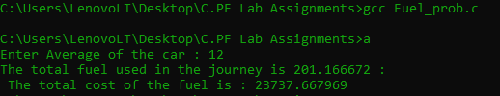

#include<stdio.h>

int main()

{

int _C1 = 118 , _C2 = 123 ;

float _avg ;

printf("Enter Average of the car : ");

scanf("%f",&_avg);

float _FC ;//for storing cost of reqiured fuel for the journey

float _TFC;//for storing cost of total fuel req in the journey

float F_R ;//for storing required fuel for single way

float _FU ;//for storing total used fuel in the trip

F_R = 1207/_avg ;

_FC = F_R*_C1;

_TFC = _FC*2;

_FU = F_R*2;

printf("The total fuel used in the journey is %f : \n The total cost of the fuel is : %f",_FU,_TFC);

return 0 ;

}